What Affects Our Well-Being?
LOQ 11-16 How do time, wealth, adaptation, and comparison affect our happiness levels?

THE SHORT LIFE OF EMOTIONAL UPS AND DOWNS

Are some days of the week happier than others? In what may be psychology’s biggest-ever data sample, social psychologist Adam Kramer (at my [DM’s] request and in cooperation with Facebook) did a naturalistic observation of emotion words in billions of status updates. After eliminating exceptional days, such as holidays, he tracked the frequency of positive and negative emotion words by day of the week. The days with the most positive moods? Friday and Saturday (FIGURE 11.12). Similar analyses of questionnaire responses and 59 million Twitter messages found Friday to Sunday the week’s happiest days (Golder & Macy, 2011; Helliwell & Wang, 2015; Young & Lim, 2014). For you, too?

Figure 11.12, Page 408

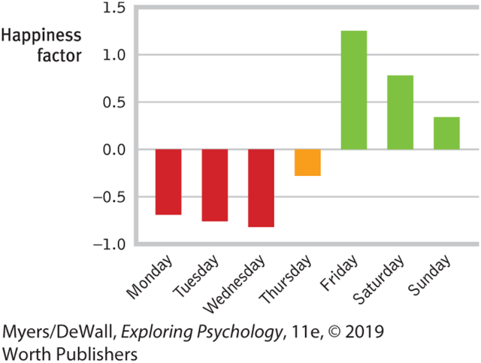

Discussion Questions:

Reflect on why you think the weekends are the happiest days? Can we believe what a person posts on social media as a true indication of their happiness? How would the COVID-19 pandemic effect this report? Do you think given the overall stress, health and emotional state of the current world, the same test today would produce different results? What do you think the chart would reveal under the current circumstances?

This response just needs to be 1-2 paragraphs or as long as you need to answer thoughtfully.

